Part A : System Documentation

1.Requirements Ellicitation

**Interviewer**: Motheo Rankopong

**Client**: Kentsenao Baseki

**Date:** 18/09/2025

**Project**: Banking System functional and non functional requirements

Transcript Excerpt:

**Interviewer:** ‘’Thank you for your time sir .To start this interview , could you please tell us the users of this new system .‘’

**Client:** ‘ well the main user will be bank employees , they will be using this system daily to interact with customers and manage their accounts.’’

**Interviewer**: ‘alright next question , what are the types of accounts you offer and what makes each one unique ?’’

**Client:** ‘We have three accounts products , mainly a Savings account where individuals cannot withdraw from it as it is for saving and earns small monthly interest of 0.25% .the second, an investment account. This one will require the customer to have BW500 to open it , as it will allow withdrawals and it also earn a much higher interest rate. Finally , a cheque account for salaried individuals as their employer`s detail will be needed and it will allow everyday deposits and withdrawals

**Interviewer**: ‘regarding the savings account , explain what the system must actively prevent any withdrawal attempt?’’

**Client:** ‘yes the system must enforce it as it is a fundamental rule of the product’’

**Interviewer**: ‘can you tell us how many accounts can an individual or company hold’’

**Client:** ‘a customer can have multiple account ; cheque, savings ,and investment’’

**Interviewer**: ‘regarding the transaction history can you tell us what shall happen there.’’

**Client:** ‘well I will be more interested in date , time , and if the transaction is a debit or credit’’

**Interviewer:** ‘lastly , can the system transfer funds between the accounts’’

**Client**: ‘No’’

**Interviewer:** ‘Alright this has been well clarified , Thank you for your input in this project sir’’

s

2. Structural UML Modelling

**Use Case Diagram**

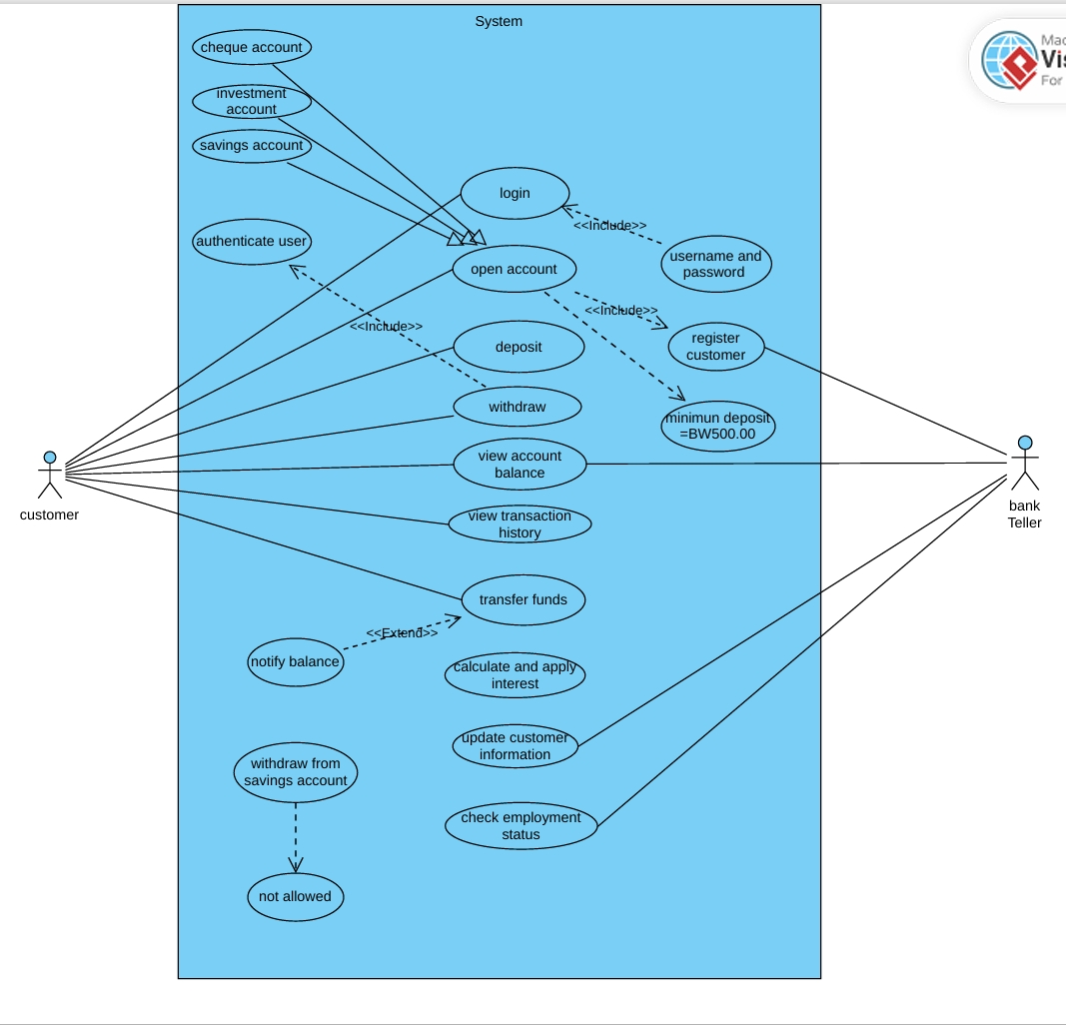

**Class diagram**

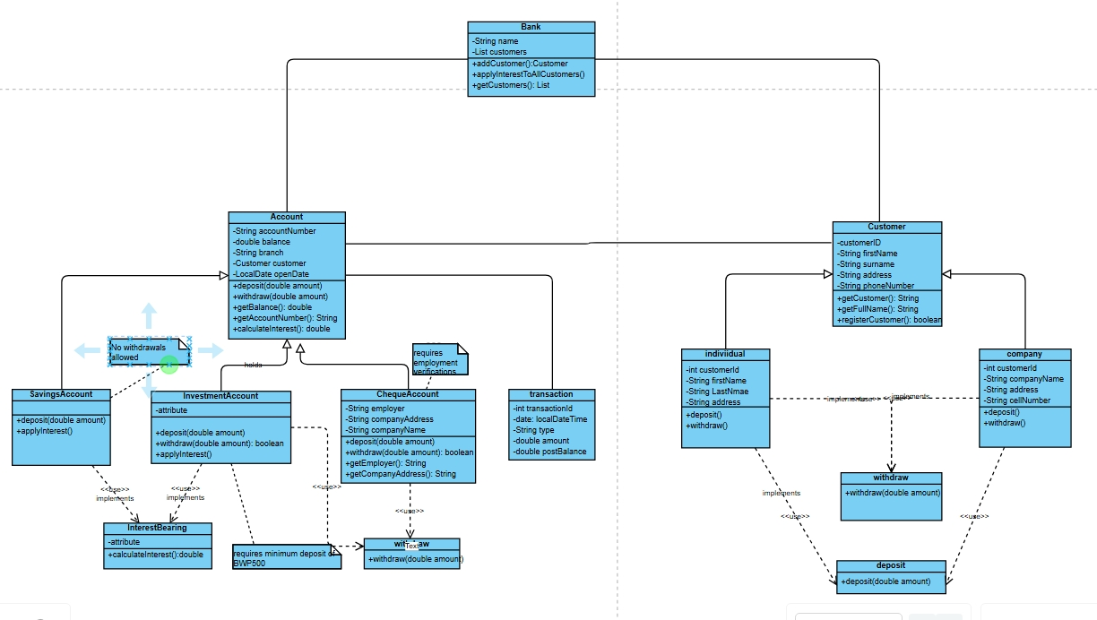

3. **Behavioural UML Modelling**

**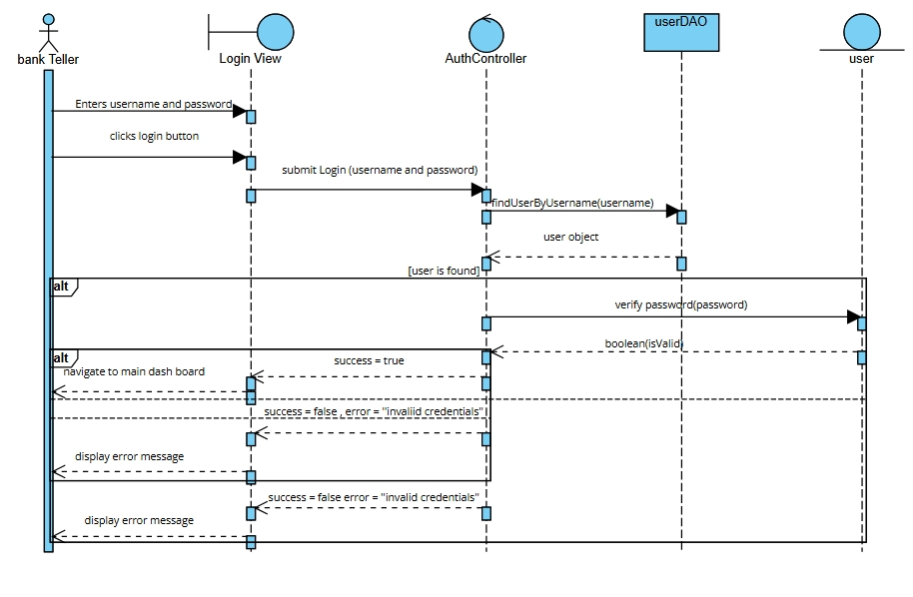

**State diagram**